Blog –Jama Software Interface for Syndeia 3.1

Dirk Zwemer (6/20/17)
One of the new features introduced in Syndeia 3.1 is our first interface to Jama Software’s requirements management tool. Syndeia means “the practice of bringing things together” and this provides a new opportunity to discuss how the impact of a powerful requirements management tool is magnified by bringing it closer to the rest of the engineering process.
One question that has arisen regularly in the development of MBSE is the relative roles of RM and other systems engineering tools. Some practitioners wondered if SysML model authoring tools would replace, or at least converge with, RM tools, but we have not seen taking place. But understanding the different use cases where one set of tools or another plays the biggest role is a useful exercise.
I would characterize the primary use cases for Jama, with respect to requirements, as Create, Collaborate and Validate.
- Create – to generate and maintain the master copy of requirements, both in permanent libraries and by project, including all the requirement attributes needed by the organization,
- Collaborate – to provide discipline and ease-of-use to the review and approval of requirements involving multiple team members, and
- Validate – to develop and incorporate an ontology of element and relationship types that allow automated checking of requirements against a standard rule set.
By contrast, the primary use cases for Syndeia, as a platform for MBSE, are Connect, Communicate and Verify.

Connect
Syndeia creates, maintains, uses and displays inter-model connections, i.e. connections between elements in different models in different tools. The first task is to create connections from Jama requirements to elements in a SysML model (MagicDraw and IBM Rational Rhapsody). Syndeia supports several different kinds of connections. The simplest, a Reference Connection, creates a traceable link between a Jama requirement and any of several kinds of SysML elements (e.g. requirements, blocks, activities, states, etc). This allows the system engineer to access the Jama web page for that requirement directly from the SysML model and to detect whether later version of it have been created.
An alternative connection type is Model Transform, which can take requirement in Jama and generate an equivalent requirement in SysML (or vice versa). These elements remain linked so that they may be compared and synced by Syndeia as one or both change over time. This applies not only to the requirement and its attributes, but to entire requirement structures where the hierarchy is maintained across tool boundaries.
Independent of connection type, the initial creation of the connection is done in the Syndeia dashboard with a simple drag-and-drop operation, as shown in Figure 1.
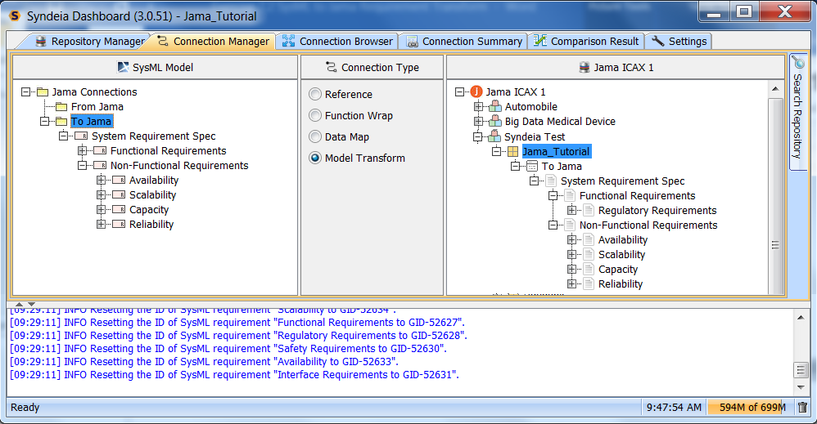
Figure 1 Drag and drop Jama requirement onto SysML package
However, this is only one part of creating the larger network of connections across the entire engineering toolset. The SysML element connected to the Jama requirement may also be connected to other elements in other tools, e.g. PLM, ALM, CAD, CAE, etc., or it may be connected to other SysML elements, which are themselves further connected. The Jama requirement becomes part of a model extending over multiple data repositories, and this gives us the opportunity to find extended chains of connection and do impact analysis.
Syndeia 3.1 has a feature where this network can be exported to a graph database and queries run. In Figure 2, we ask for commit elements in GitHub, a software configuration management repository, are connected to a particular Jama requirement, “Search”. The results show one GitHub commit (the red circle, id lower left), connected to a SysML block “Flight SW”, which satisfies a SysML requirement “Search” connected by model transform to the original Jama requirement. These capabilities make it possible to find chains of connection and potential impact quickly across large models in real engineering production applications.
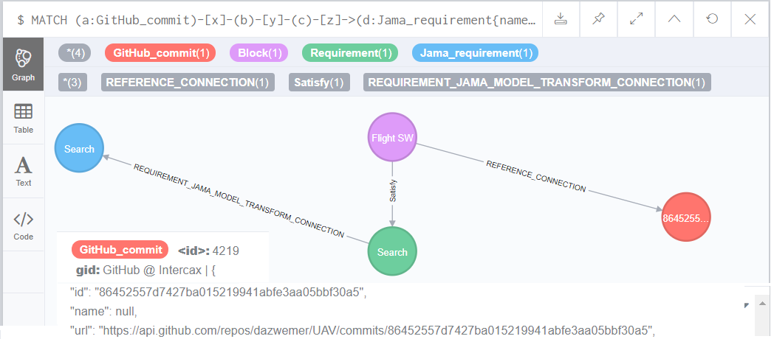
Figure 2 Neo4j Graph Query for GitHub commits connected to Jama requirement “Search”

Communicate
To communicate effectively, two people must speak the same language. Thisa is equally true of two software tools. It’s widely agreed that capturing requirements in a simple text statement is very limiting. The OMG SysML standards effort is working to broaden the possibilities in this area, but there are already ways in which the requirements in SysML can be linked to forms that translate more effectively into other domains via Syndeia. For example, in Figure 3, we see how requirements can be communicated to CAD as geometry. The block Payload represents a cylindrical bounding box for payload components and a spherical locus within it for the final payload center of gravity. Syndeia converts this into a starting CAD file in Siemens NX, providing geometric requirements to the CAD designer that do not require interpretation and translation.
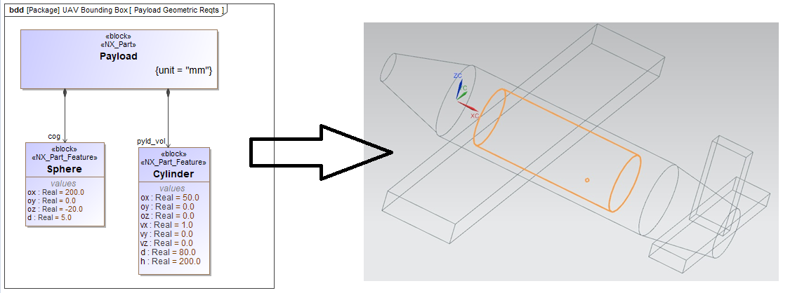
Figure 3 Requirements by Geometry, SysML to NX CAD

Another approach is to capture a quantitative requirement as a SysML parametric constraint, as in the top part of Figure 4. The constraint block on the right is a conditional expression that mirrors the text statement in the requirement on the right returning 1 if true, 0 if false.
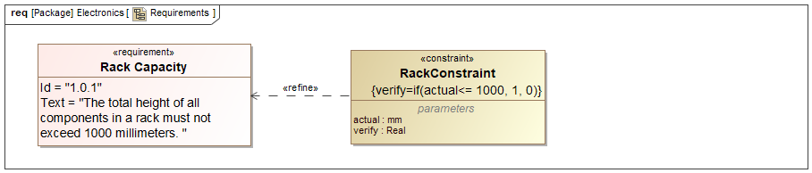
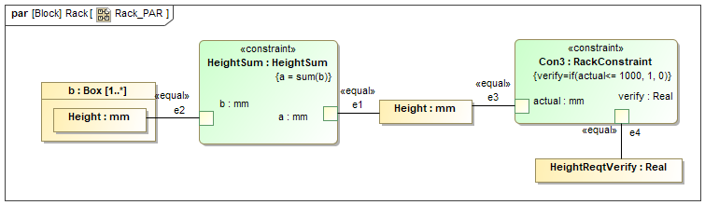
Figure 4 Requirements verification by SysML parametrics

Verify
The bottom part of Figure 4 shows how such a mathematical constraint can be directly verified by SysML parametrics, drawing on values in the SysML model, which in turn may be linked by Syndeia to CAD mass properties, PLM attributes, simulation results and other external values. The goal is rapid, automated verification of requirements on a daily basis, allowing a MBSE equivalent to agile software engineering.
There is still work to be done in reaching this goal. In particular, the work on property-based requirements by the SysML standards committee will be critical in how quantitative value transfer will be implemented in the final solutions. However, the trend in the MBSE community is to extend the impact of RM tools by making them more fully part of the engineering process. I believe the Jama interface for Syndeia is a significant step in that direction.

About the Author
Dr. Dirk Zwemer (dirk.zwemer@intercax.com) is President of Intercax LLC (Atlanta, GA), a supplier of MBE engineering software platforms like Syndeia and ParaMagic. He is an active teacher and consultant in the field and holds Level 4 Model Builder-Advanced certification as an OMG System Modeling Professional.
For further information, visit us at www.intercax.com or contact us at info@intercax.com.

